SpendWise

Project Title
SpendWise – A Simple Backend Learning Project using Node.js, Express, MongoDB, and JWT
Introduction to SpendWise:
SpendWise is a backend application developed to help beginner developers understand how to build secure RESTful APIs using Node.js, Express.js, MongoDB, and JWT authentication. The main aim of this project is to implement user authentication and basic CRUD operations in a simple and structured way. This system allows users to register, log in securely, and manage their expense transactions. Through this project, students can gain practical knowledge of how backend applications are designed and how real-world server-side systems work.
Project Objectives:
To implement secure user authentication using JWT (JSON Web Token).
To allow users to perform basic CRUD operations such as creating, reading, updating, and deleting transactions.
To demonstrate database integration using MongoDB with Mongoose.
To implement protected routes using middleware for security.
To maintain a simple, structured, and beginner-friendly backend architecture for learning purposes.

Project Instruction
SpendWise is a backend-only project built using Node.js and Express.
Quick Start:
npm init
npm install
npm run dev
Project Requirements:
● Basic knowledge of JavaScript and Node.js.
● Node.js and npm installed on the system.
● MongoDB database (MongoDB Atlas or local MongoDB).
● A code editor such as Visual Studio Code.
● API testing tools like Thunder Client or Postman.
● Basic understanding of REST APIs and backend development.

Pre-requisites:
Software Requirements
Software | Purpose
Node.js | JavaScript runtime for backend
MongoDB | NoSQL database for data storage
npm | Package manager
Git | Version control system
Code Editor | VS Code or similar

Knowledge Requirements
- JavaScript ES6+
- Node.js and Express.js
- MongoDB and Mongoose
- JWT authentication
- Basic REST API concepts
- Git basics

Thumbnail for Project
- A simple backend project thumbnail representing:
Node.js + Express + MongoDB + JWT + CRUD APIs

Project Architecture Image
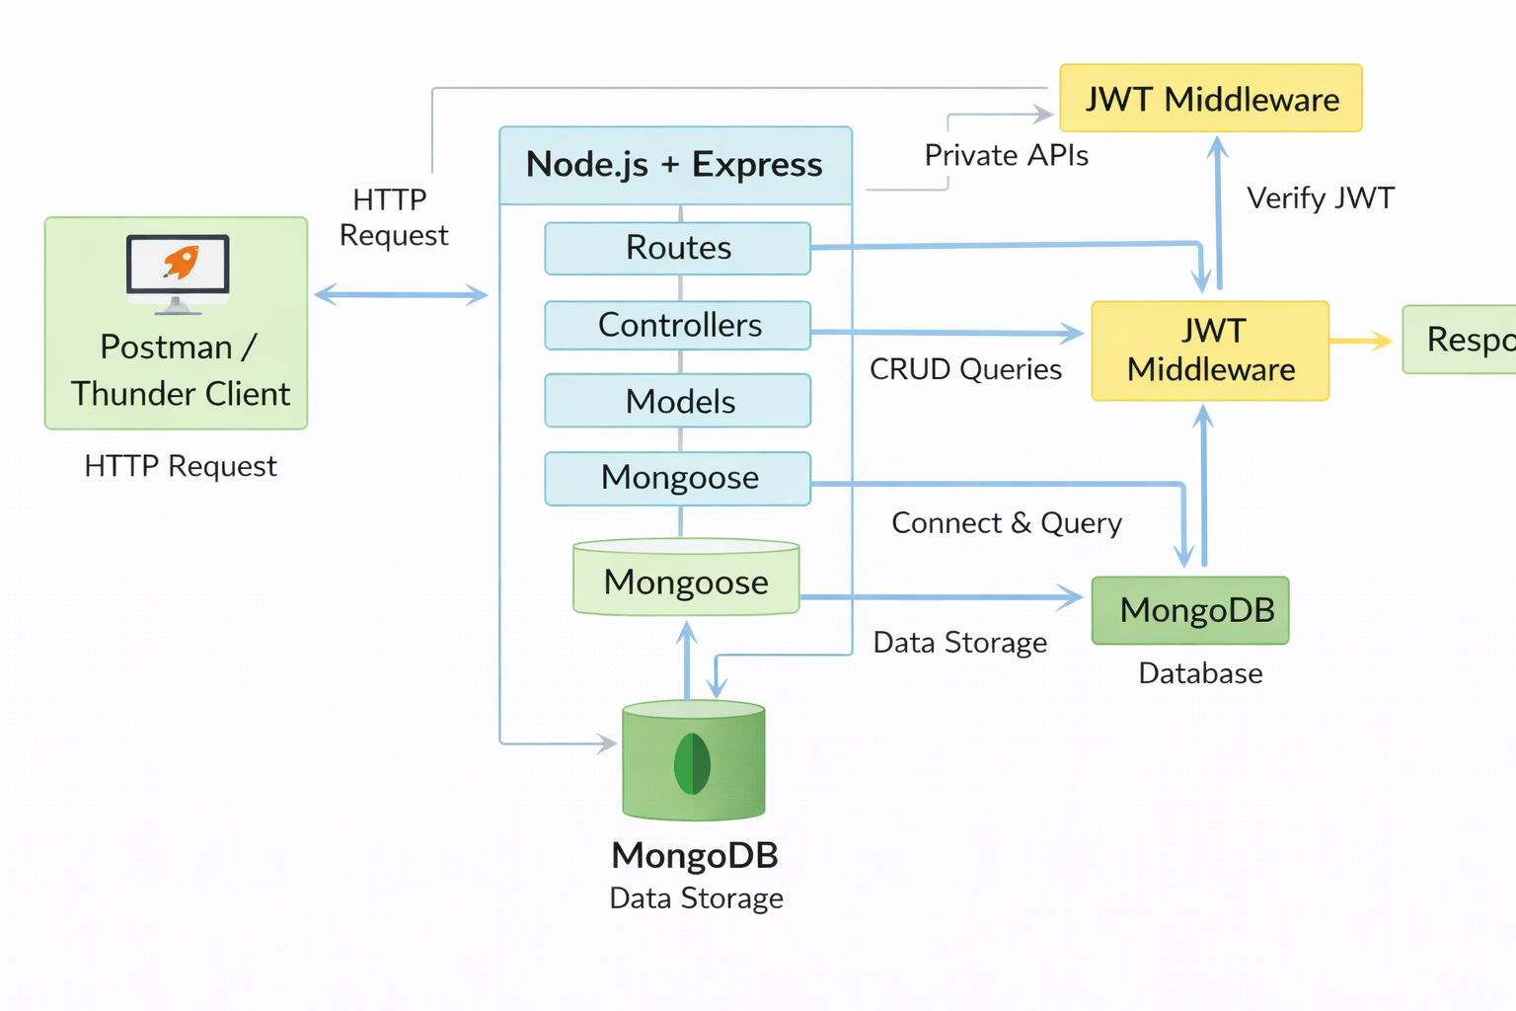

Technical Architecture
Backend Architecture (Node.js + Express)
- Controllers: Handle business logic for authentication and CRUD
- Models: Mongoose schemas for User and Transaction
- Routes: API endpoints for auth and CRUD operations
- Middleware: JWT verification and request protection
- Configuration: Database connection and environment variables

Database Architecture (MongoDB)
- Users Collection:
_id, name, email, password (hashed), createdAt
- Transactions Collection:
_id, userId (FK), title/description, amount/value, createdAt
- Relationship:
Many Transactions belong to One User

ER Diagram
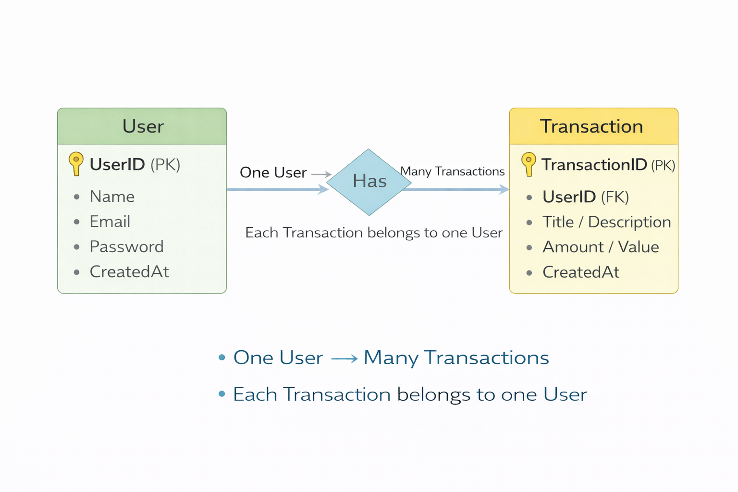

Features

# | Feature | Description
1 | User Authentication | JWT-based registration and login
2 | CRUD Operations | Create, Read, Update, Delete transactions
3 | Protected Routes | Secure APIs using JWT middleware
4 | MongoDB Integration | Store and fetch data using Mongoose

Roles and Responsibilitie

Student / Developer
● Develop and implement the backend application using Node.js and Express.js.
● Design and create RESTful APIs for user authentication and transaction management.
● Test the APIs using tools such as Postman or Thunder Client to ensure proper functionality.
● Maintain and manage the project source code by pushing updates to GitHub.

System (Backend):
- Authenticate users using JWT
- Handle CRUD operations
- Store and fetch data from MongoDB
- Protect private routes

Users Flow:
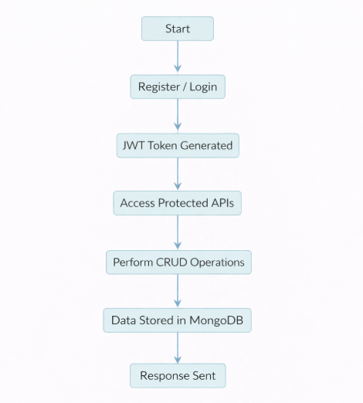

PROJECT SETUP AND CONFIGURATION

Folder Structure
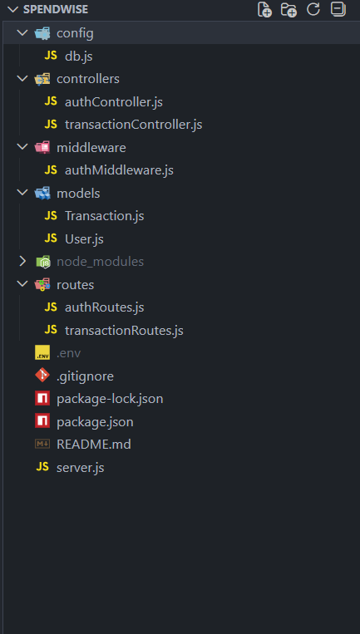

Project Setup
1. Install required tools:
- Node.js
- MongoDB
2. Create project folders:
- server folders (models, routes, controllers, middleware, config)

3. Install Backend Packages:
- Express
- Mongoose
- Cors
- Jsonwebtoken
- Bcrypt
- Dotenv

BACKEND DEVELOPMENT
- Setup Express server
- Create server.js file
- Create .env file and define PORT and DB URL
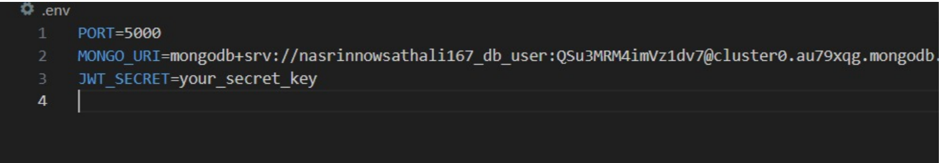
- Configure middleware (cors, express.json)
- User Authentication:
  - Create Register and Login routes
  - Generate JWT token
  - Protect routes using middleware

- Define API Routes:
  - Auth routes
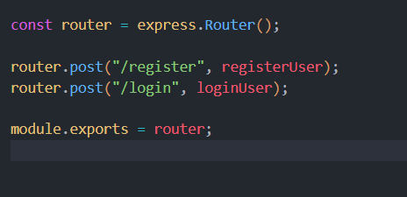
  - Transaction CRUD routes

- Implement Data Models:

  - User schema
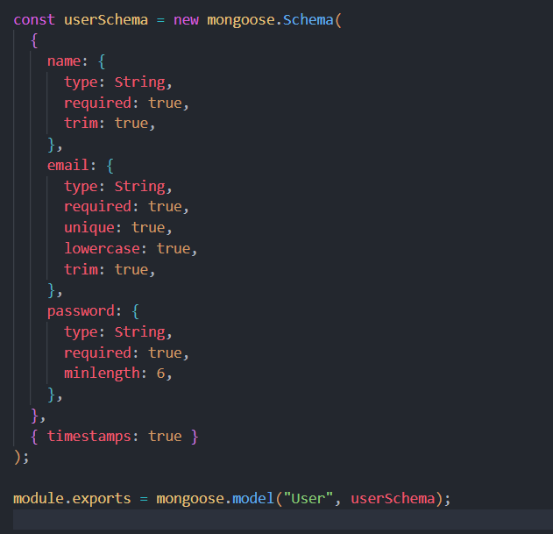

  - Transaction schema
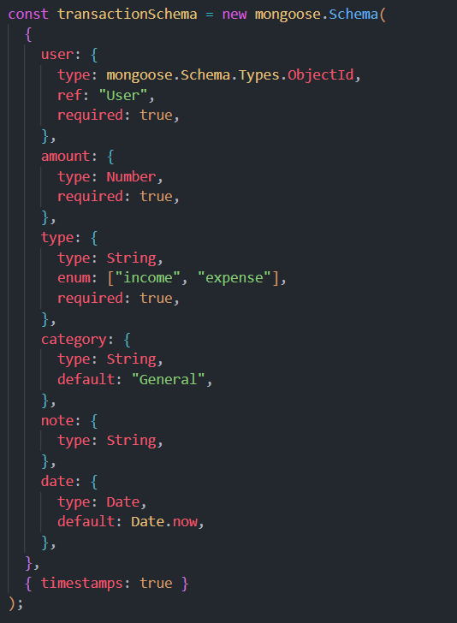

- Implement CRUD operations
- Add basic error handling

DATABASE DEVELOPMENT

Configure MongoDB
- Use MongoDB Atlas or local MongoDB
- Store connection URL in .env file
- Connect using Mongoose

Create Database Connection
- Create a config file for DB connection
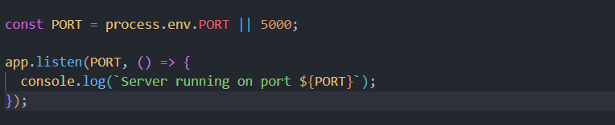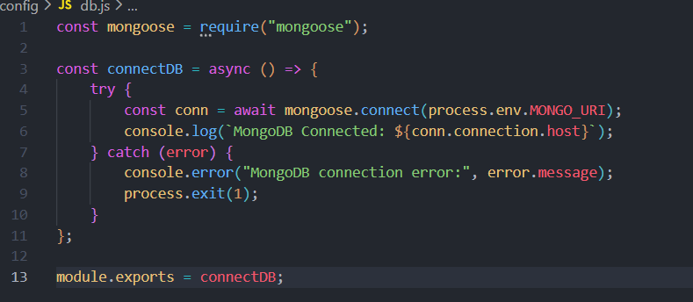
- Use mongoose.connect()
- Handle success and error cases

Create Schema and Models

User Model:
- Name
- email
- password

Data / Transaction Model:
- userId
- title / description
- amount / value
- timestamps

PROJECT EXECUTION

Project Execution Steps:
- Start MongoDB
- Run backend server
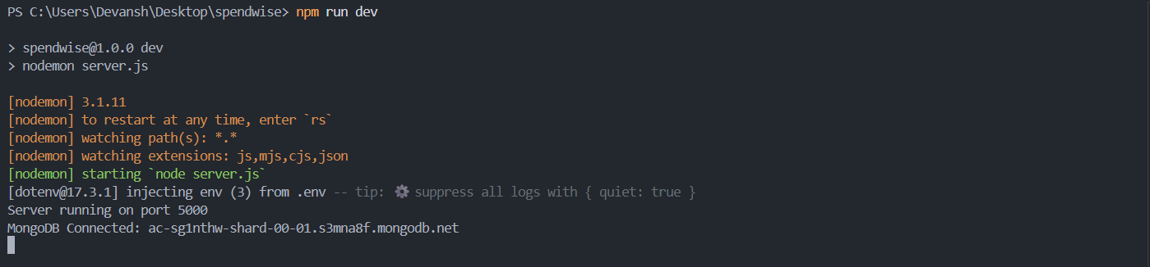

- Test Register API
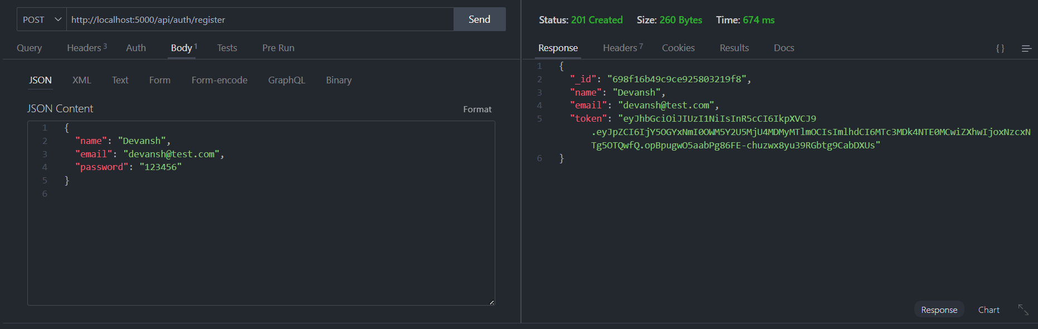

- Test Login API
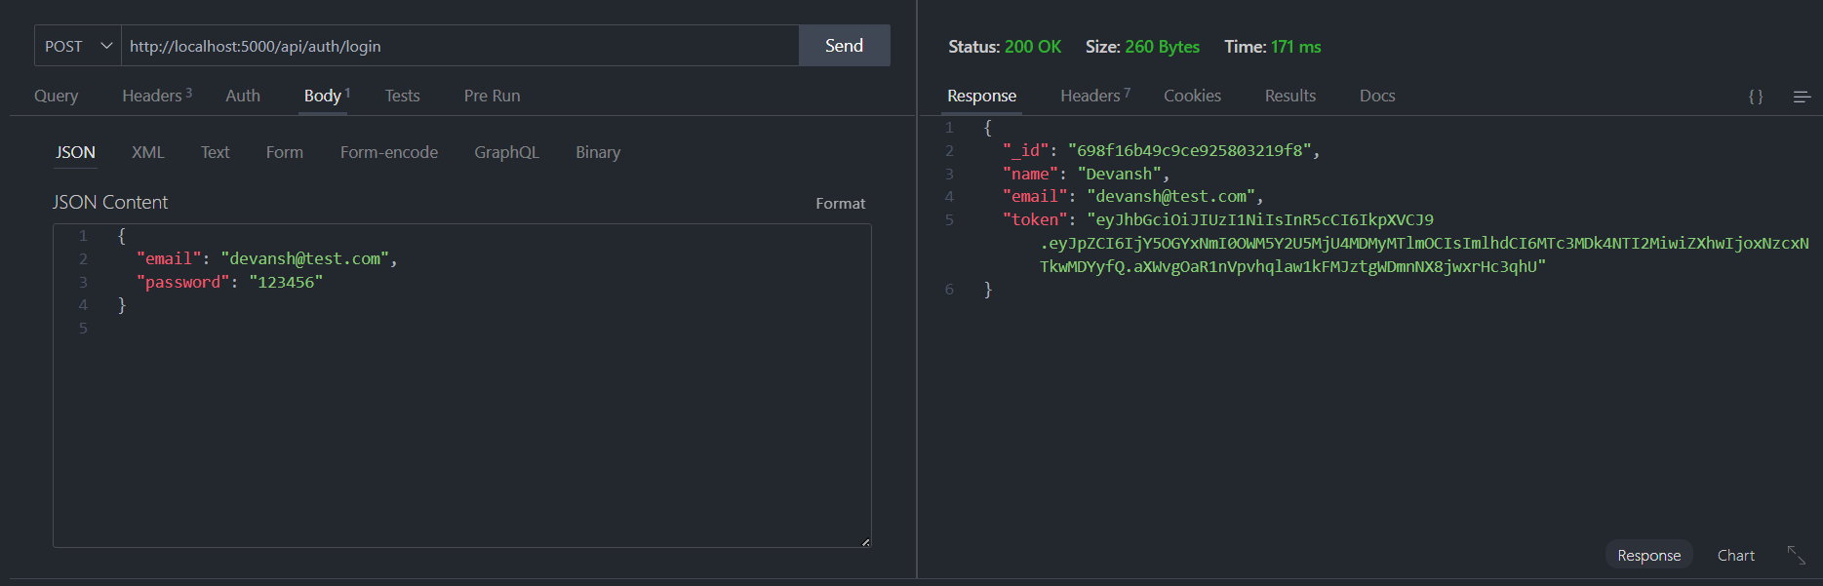

- Copy JWT token
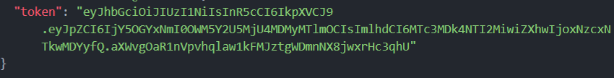
- Use token to access protected CRUD APIs
- Perform Create, Read, Update, Delete operations

OUTPUT SCREENSHOT

- Register API

- Login API
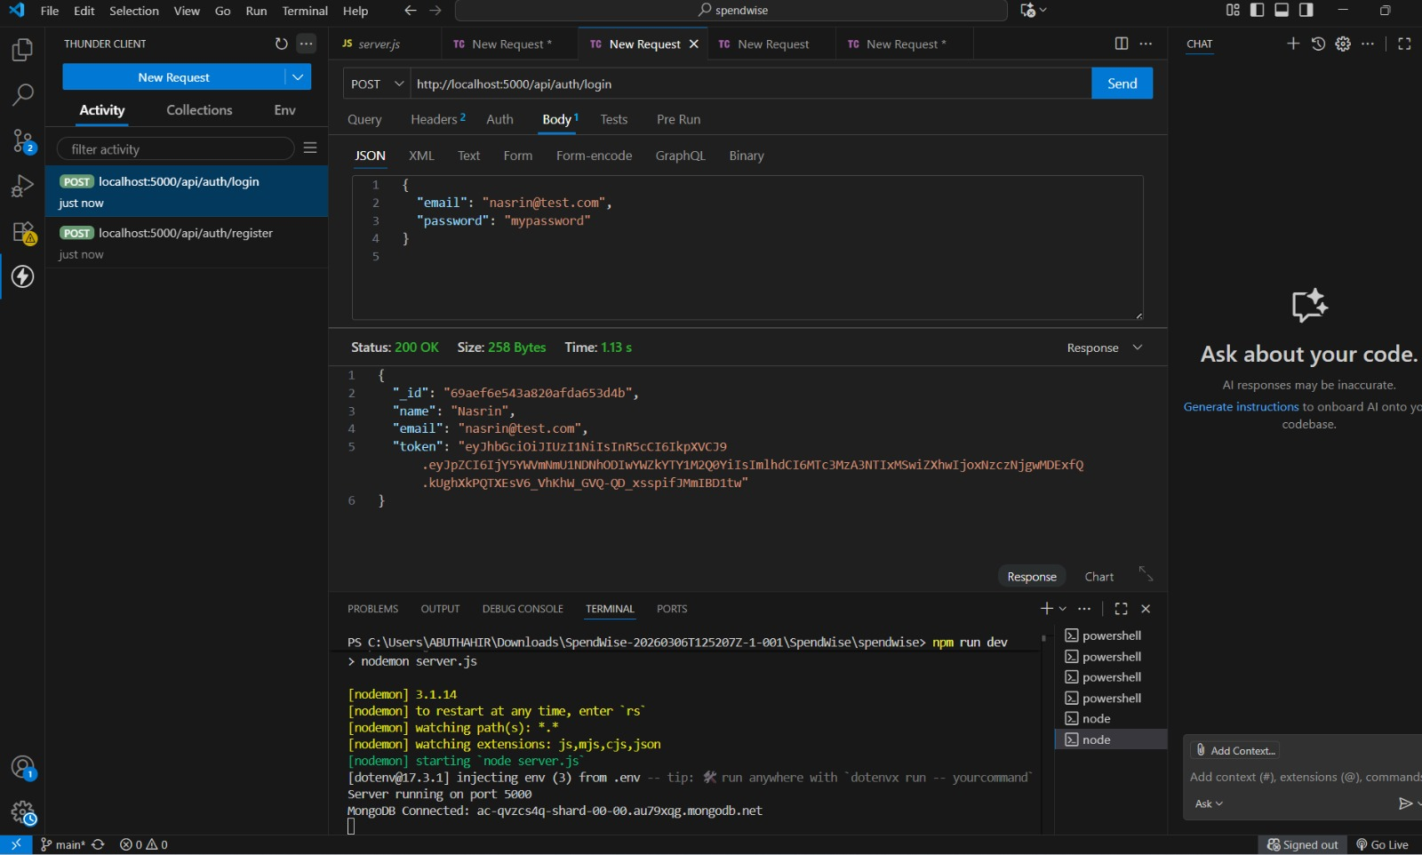

- Create Transaction
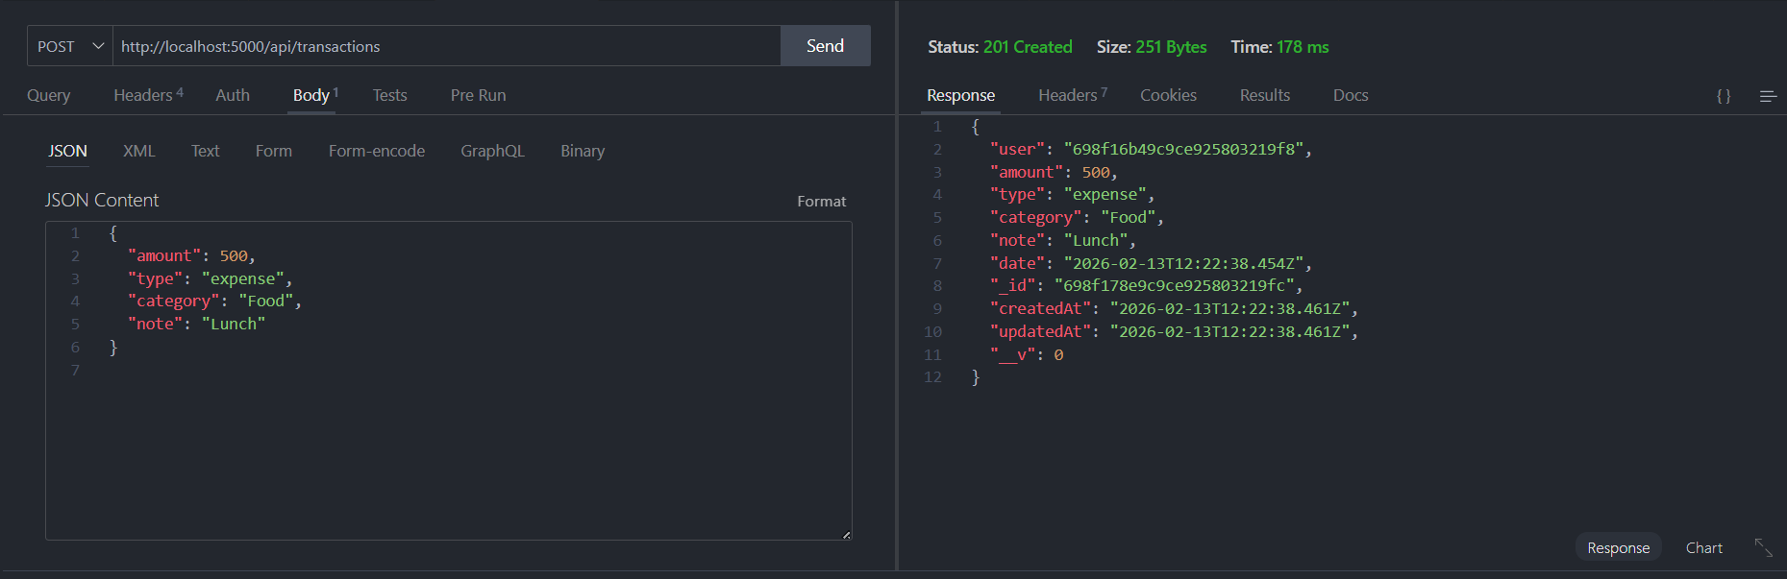

- Get information
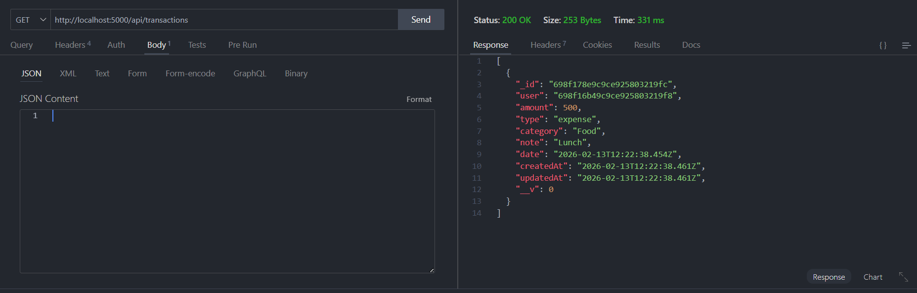

- Update API
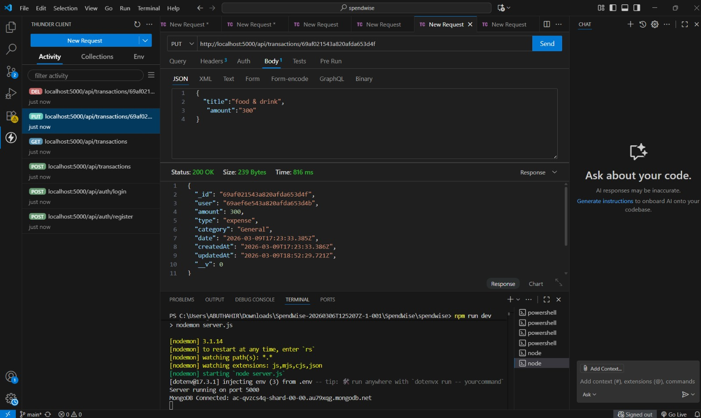

- Delete API
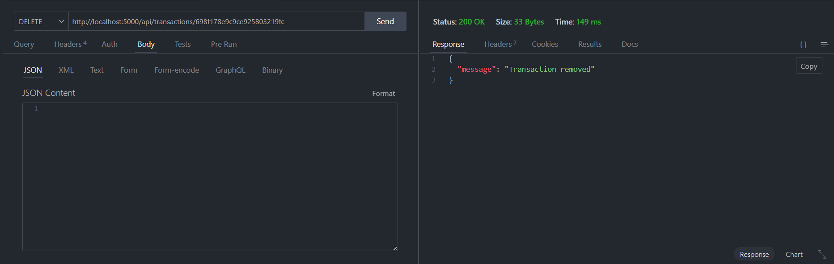

Project Demo Video
SpendWise (video).mp4

Drive Link : SpendWise

